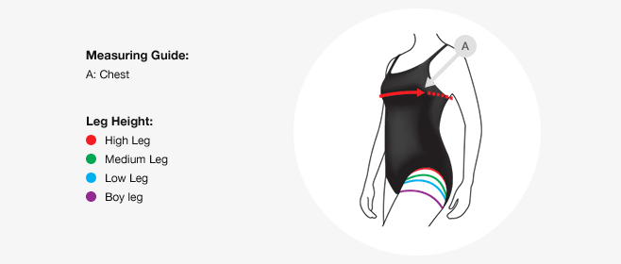

Speedo Women
Our women's swimwear sizing is based on your chest measurement in inches and we have included an approximate conversion to UK dress size to make it easier to find the size that's right for you.
Speedo Size | Chest | UK  (approx. conv.) | De | Fr | It | Au
28 | 28" / 70 | 4 - 6 | 32 | 34 | 38 | -
30 | 30" / 75 | 6 - 8 | 34 | 36 | 40 | -
32 | 32" / 80 | 8 - 10 | 36 | 38 | 42 | 8
34 | 34" / 85 | 10 - 12 | 38 | 40 | 44 | 10
36 | 36" / 90 | 12 - 14 | 40 | 42 | 46 | 12
38 | 38" / 95 | 14 - 16 | 42 | 44 | 48 | 14
40 | 40" / 100 | 16 - 18 | 44 | 46 | 50 | 16
42 | 42" / 105 | 18 - 20 | 46 | 48 | 52 | 18
44 | 44" / 110 | 20 - 22 | 48 | 50 | 54 | 20
46 | 46" / 115 | 22 - 24 | 50 | 52 | 56 | 22

